Software Requirements Specification

for

Banquet Management System (Web Application)

Prepared by Muhmmad Qasim

PAFKIET

2-2-2020

Table of Contents

Table of Contents ​ii

Revision History ii​

- ​Introduction ​1

1.1 | ​Purpose ​1
1.2 | ​Document Conventions ​1
1.3 | ​Intended Audience and Reading Suggestions ​1
1.4 | ​Product Scope | ​1
1.5 | ​References | ​1
2. | ​Overall Description |  | ​2
2.1 | ​Product Perspective |  | ​2

Page 1 of 6

2.2 | ​Product Functions |  | ​2
2.3 | ​User Classes and Characteristics |  |  |  | ​2
2.4 | ​Operating Environment |  | ​2
 |  |  |  |  |  | ​
3. | ​External Interface Requirements |  |  |  |  | ​3
3.1 | ​User Interfaces | ​3
3.2 | ​Software Interfaces | ​3
4. | ​System Features |  | ​4
4.1 | ​System Feature 1 |  | ​4
4.2 | ​System Feature 2 (and so on) |  |  | ​4
5. | ​Other Non functional Requirements |  |  |  |  | ​4

Revision History

NameDateReason For ChangesVersion


1. Introduction

1.1 Purpose

The purpose of making banquet management system is to make things easy for the management to store and retrieve data and to keep the check and balance of expenses and the staff.

Page 2 of 6

1.2 Document Conventions

Heading: Times New Roman (11 pt)
Descriptive Text: Ariel (9 pt,)

1.3 Intended Audience and Reading Suggestions

This document is for:
- Developer
- Team lead
- Administrator/Manager

The sequence of this document in mention in the table of contents on page 1 and 2.

1.4 Product Scope

This application is used by the Administrator/manger of the banquet. The main objective of this application is to make it easier for the managing body to register new bookings and the keep the record of them and with that it also allows the administrator of the system to keep the record and track of the banquet's staff and the expenses .

1.5 References

The view of the system will be like:
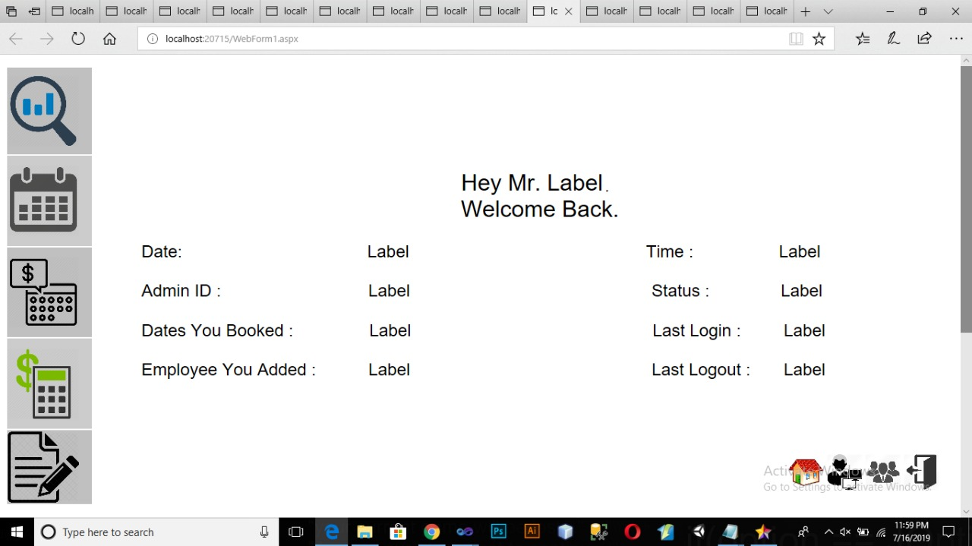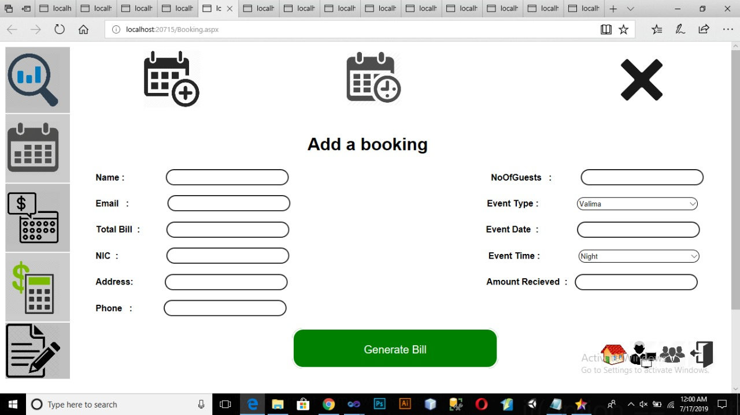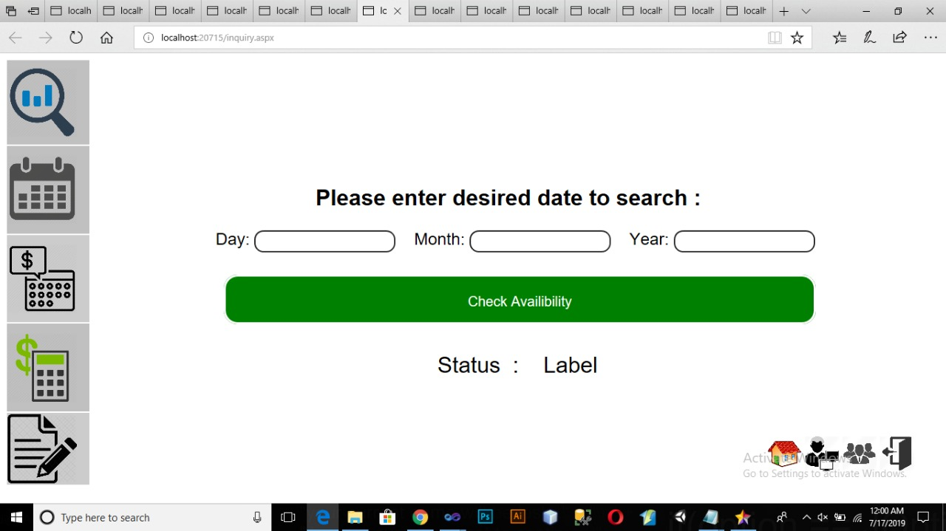

2. Overall Description

2.1 Product Perspective

This is a new software based on the process which is followed by banquet management for registering new bookings and the keeping track of staff and the expenses These days it is noticed that there’s no relevant management system for banquets, all of their management need a lot of men to be handled. All of their accounts and records are written in registers which is then hard to find records and their updating process is quite bad. And there exist a threat for important data to be lost and if not written, it might be forgotten at times.

2.2 Product Functions

The functions of this applications are:
- Check availability
- Add Booking , Search Booking , Cancel Booking
- Billing Search , Billing Payment
- Accounts , Current Balance , Transactions
- Employee , Add Employee , delete employee
- Daily Record, Search - Insert : Expenses
- Monthly Record, Search - Insert : Profit, Received, Expenses

2.3 User Classes and Characteristics

Classes that will be used in this application are:
- Billing
- Account
- Employee
- Record
- Connection
- Login
- Booking

2.4 Operating Environment

This application is a web based application and it will work on any browser but the most preferred browser will be Goggle Chrome. The hardware and operating system requirement for running this application will be same as it is for running Chrome.

Page 3

3. External Interface Requirements

3.1 User Interface
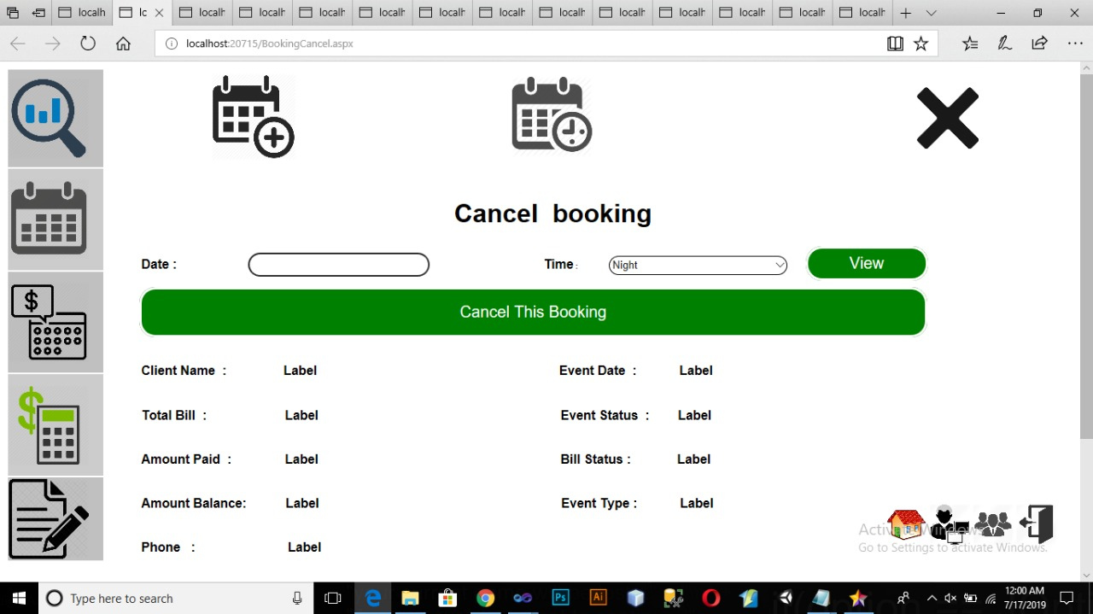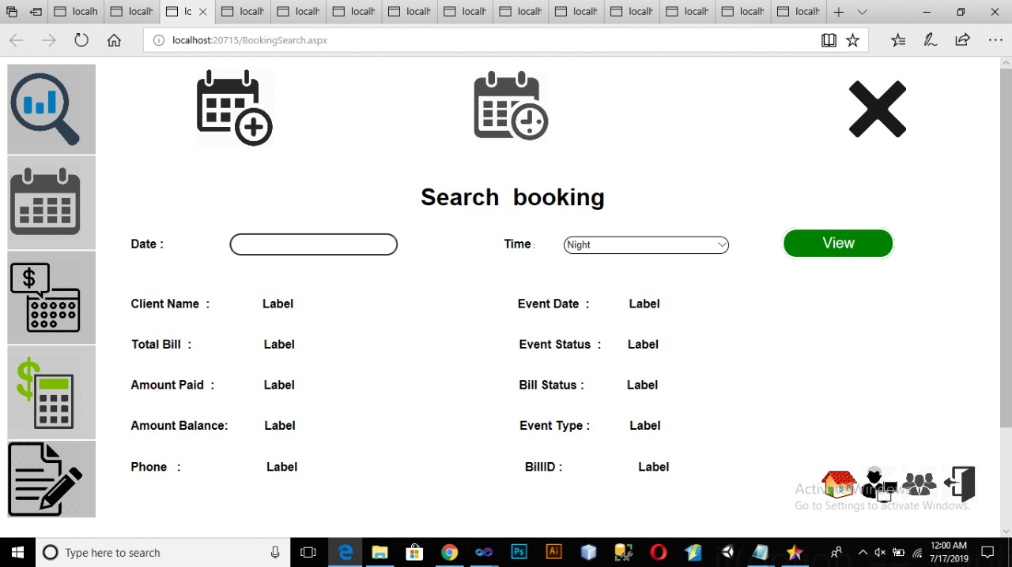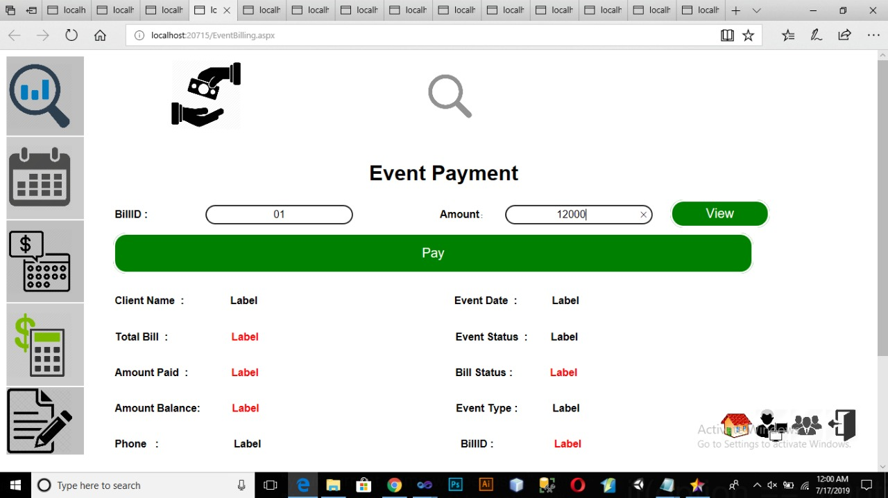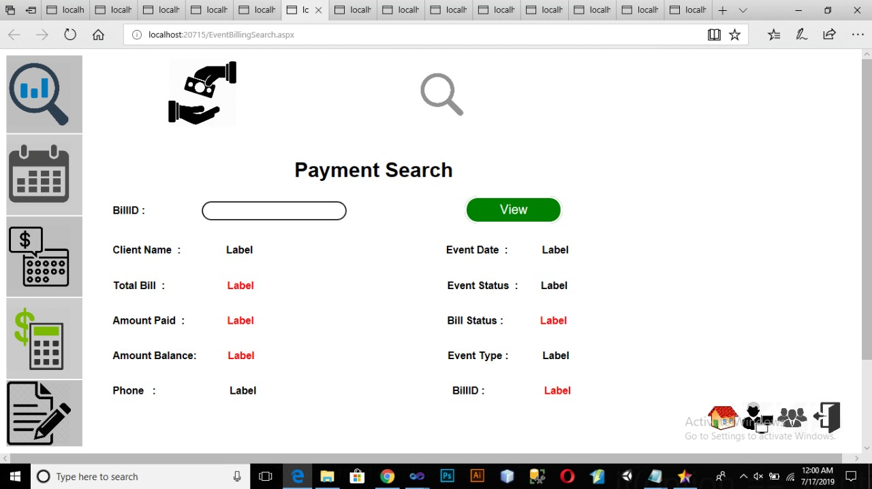
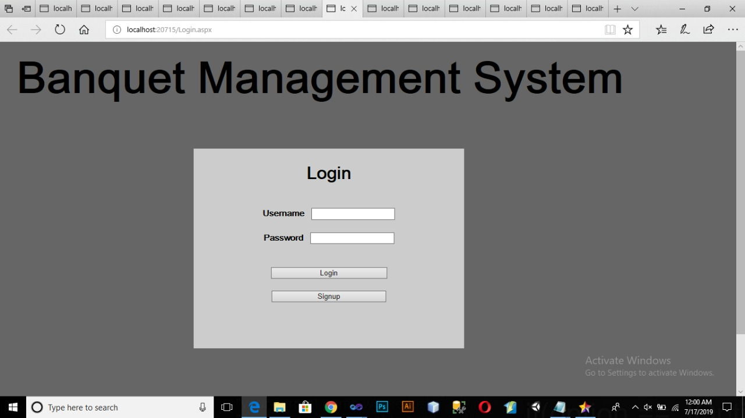

3.2 Software Interfaces

The application will be designed using the on ASP and will include java script, bootstrap, HTML, CSS and SQL Management System.

Page 4 of 6

4. System Features

4.1 System Feature 1

4.1.1 ​Description and Priority

<Provide a short description of the feature and indicate whether it is of High, Medium, or Low priority. You could also include specific priority component ratings, such as benefit, penalty, cost, and risk (each rated on a relative scale from a low of 1 to a high of 9).>

4.1.2 ​Stimulus/Response Sequences

< List the sequences of user actions and system responses that stimulate the behaviour defined for this feature. These will correspond to the dialogue elements associated with use cases.>

4.1.3 ​Functional Requirements

Inquire : The client will come and inquire about the booking and its the first basic requirement.

Availability : after inquire the admin will check the availability of desired dates of client and if the dates are available then there will be a booking process in which the admin will fill up the form of the clients details and the payment as well and at the end of this process the client will get a receipt of the payment and other important details. And after booking there is an option of cancelling that booked slot as well.

Accounts : another function of the program is the it has all account and transaction details of the banquet which is use full to keep the check on the current balance of the banquets income.

Employee : Another most important function of the program is that it also has the record of the employees and can add and delete the record of employees.

Daily and Monthly Records : the program also has the feature of showing daily and monthly records of transaction and the total balance as well and you can search the transaction specifically as well .

5. Other Non functional Requirements
- Account setting options for Administrator
- Search options
- Database connections
- Database relationships
- Constraints
- Backup
- Data save
- Grid view of administrator.

Page 6 of 6

